TEMPAT MENARIK DI SELANGOR

1.TAMAN BOTANI NEGARA ( rate 4.1/5 )

<https://www.youtube.com/watch?v=yiQQAUf2kL0>

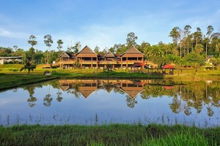

Sultan Salahuddin Abdul Aziz Mosque ( rate 4.8 /5)

<https://www.youtube.com/watch?v=Payerhae0Lk>

Sunway Lagoon ( rate 4.5/5)

<https://www.youtube.com/watch?v=H9r5rCfJOZo>

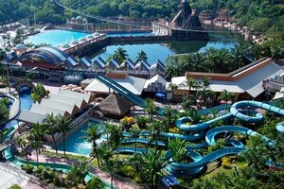

Batu Caves ( rate 4.4/5)

<https://www.youtube.com/watch?v=FUFJnVsDpiY>

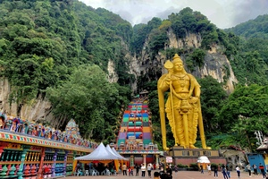

Farm in city ( 4.3/5)

<https://www.youtube.com/watch?v=rFrUudda7YU>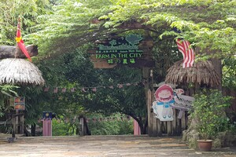

National Zoo ( 4.1/5)

<https://www.youtube.com/watch?v=RSWHGcC-6nE>

Raja Tun Uda Library (rate 4.6/5)

<https://www.youtube.com/watch?v=K7mzXav1Lr4>

I City (rate 4.3/5)

<https://www.youtube.com/watch?v=h2eqGqrLAjU>

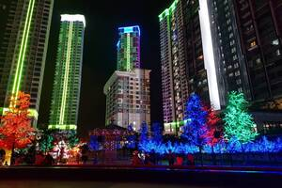

Shah alam lake garden (4.5/5)

<https://www.youtube.com/watch?v=I-A2Hk1C27A>

Kampung kUantan Fireflies (4.7/5)

<https://www.youtube.com/watch?v=5Fjl2LmQ47c>

Sungai Chiling Fish Sanctuary (4.4/5)

<https://www.youtube.com/watch?v=D2uhNW3WPaI>

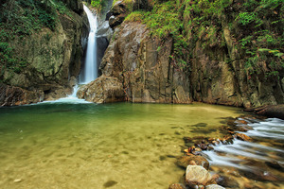

Shah Alam Community Forest Trail head ( 4.4/5)

<https://www.youtube.com/watch?v=JqEuy0Q5npY>

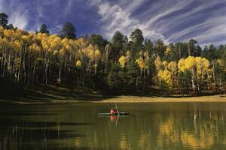

## Muzium Orang Asli Gombak (MOAG) 4.3/5

## <https://www.youtube.com/watch?v=jwKW8Wb79HU>

## Gua Damai Extreme Park

## <https://www.youtube.com/watch?v=C2WUD79dZMQ>

mudtrekker paintball park shah alam 4.6/5

<https://www.youtube.com/watch?v=FbGxmNrMZa4>

Zipline Shah Alam 4.6 /5

<https://www.youtube.com/watch?v=xNhrkOT36Ns>

Minnature Malaysia 4.7/5

<https://www.youtube.com/watch?v=Xu03OGa7llU>

Uptown Shah Alam 4.1/5

<https://www.youtube.com/watch?v=qRzFT_0M7N8>

Mitsui Outlet Park KLIA Sepang 4.3/5

<https://www.youtube.com/watch?v=Rb1DFAFbjOA>

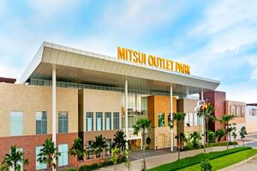

Taman Eko Rimba Kanching Waterfalls 4.3/5

<https://www.youtube.com/watch?v=IbuL15JzuIU>

